**EXPERIMENT 11**

Demonstrate Infrastructure as a Service (IaaS) by creating a resources group using a Public Cloud Service Provider (Azure), configure with minimum CPU, RAM, and Storage

first we can sign in into Azure

home page will appears like this now click on resource group

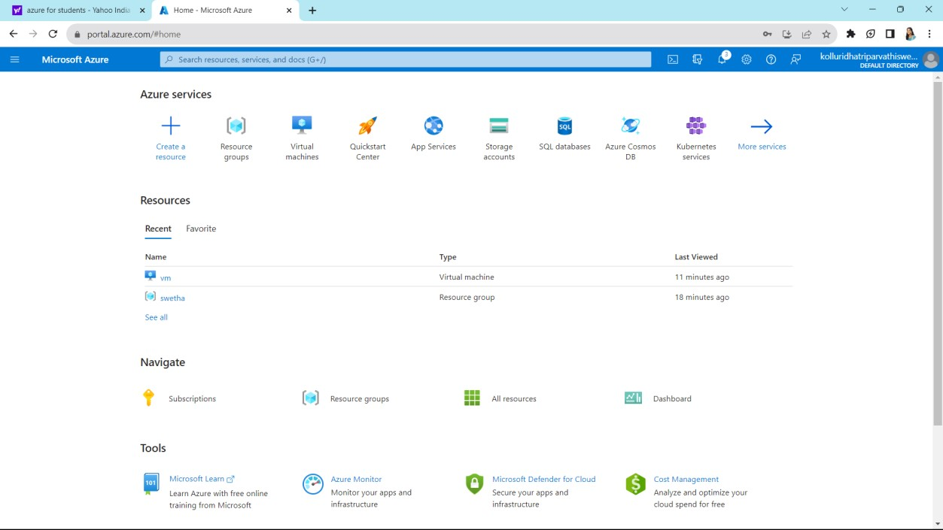

Now click on create which is on left side top

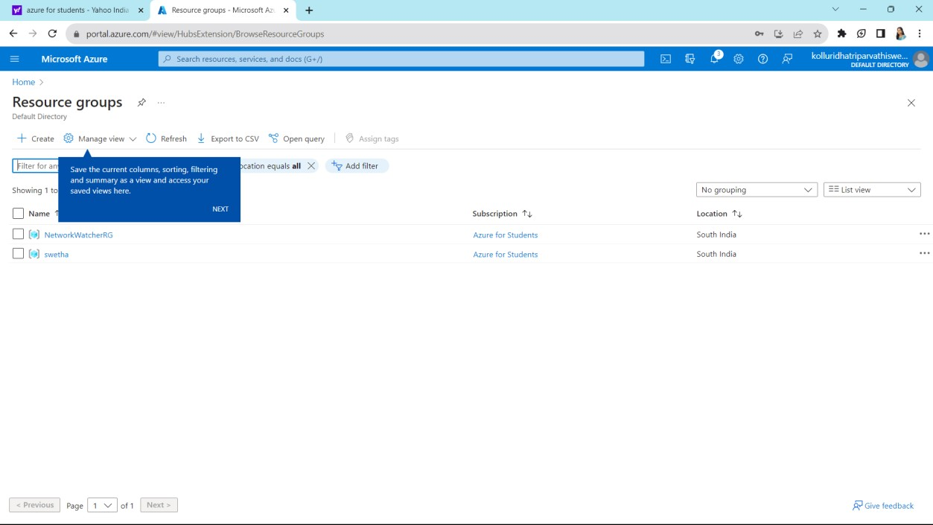

Fill up the required columns and click on next which is on bottum

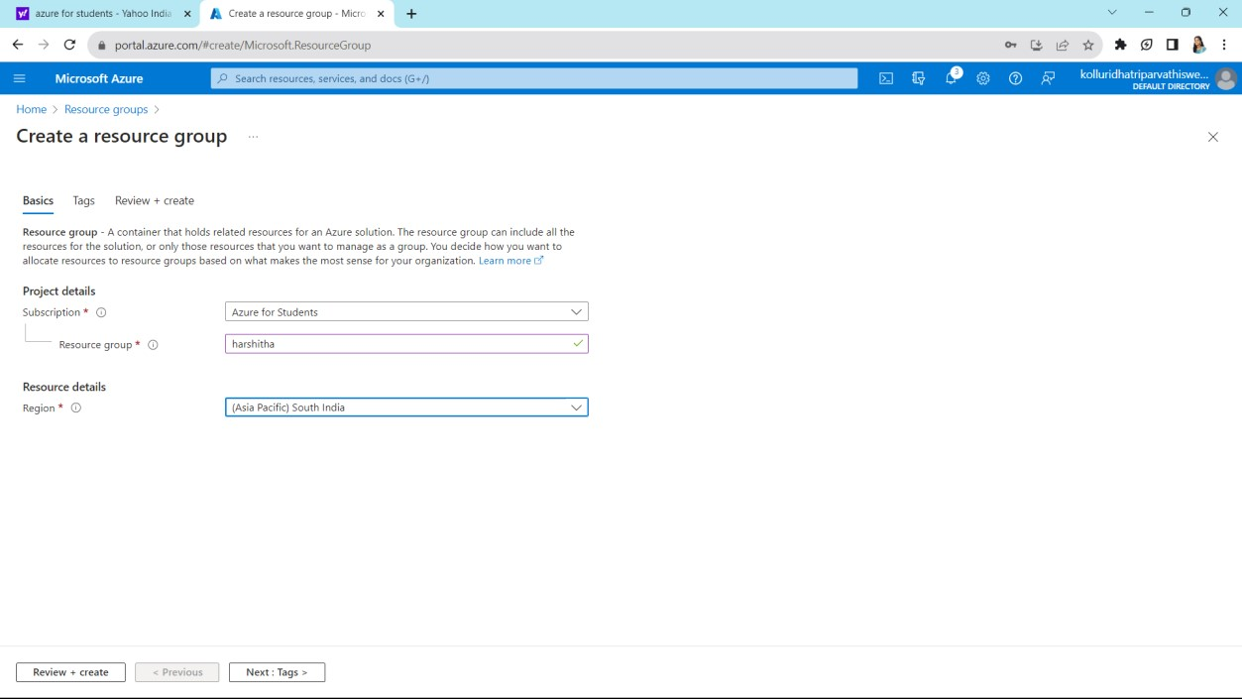

Give some names and values and the click on next

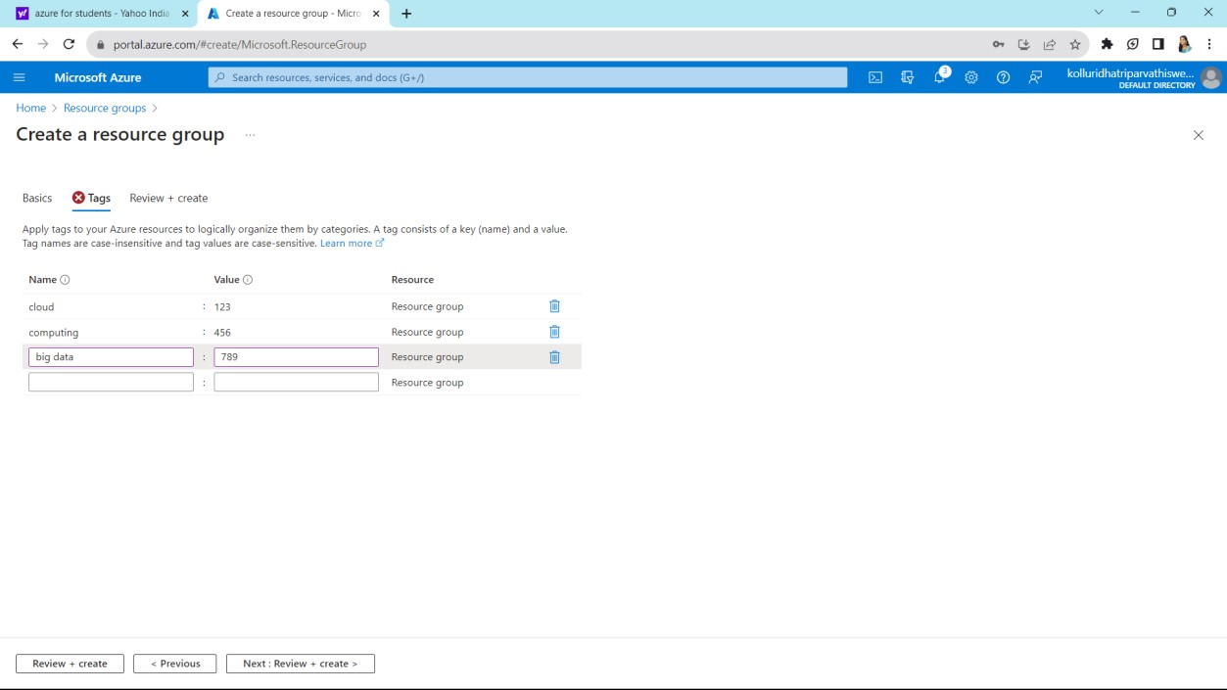

It shows your summary which filled in previous steps verify that and click on create which is on left side bottum

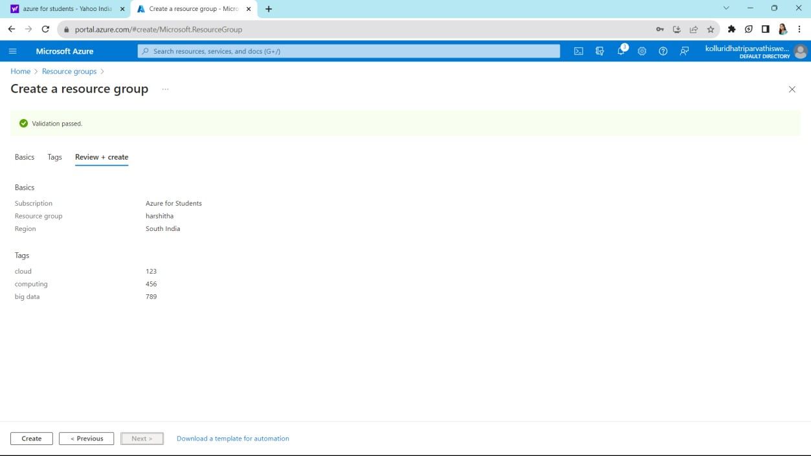

Our required resource group was created and listed below

